Cafe Inbound & Outbound Voice Automation System
GoHighLevel | Synthflow | Voice Agents | CRM | Appointment Booking | Email

Project Overview
Built a GoHighLevel automation system for a cafe to manage inbound and outbound customer calls, appointment booking, follow ups, and customer communication.
The setup connects Synthflow voice agents with GoHighLevel workflows to keep the complete process organized inside the CRM.

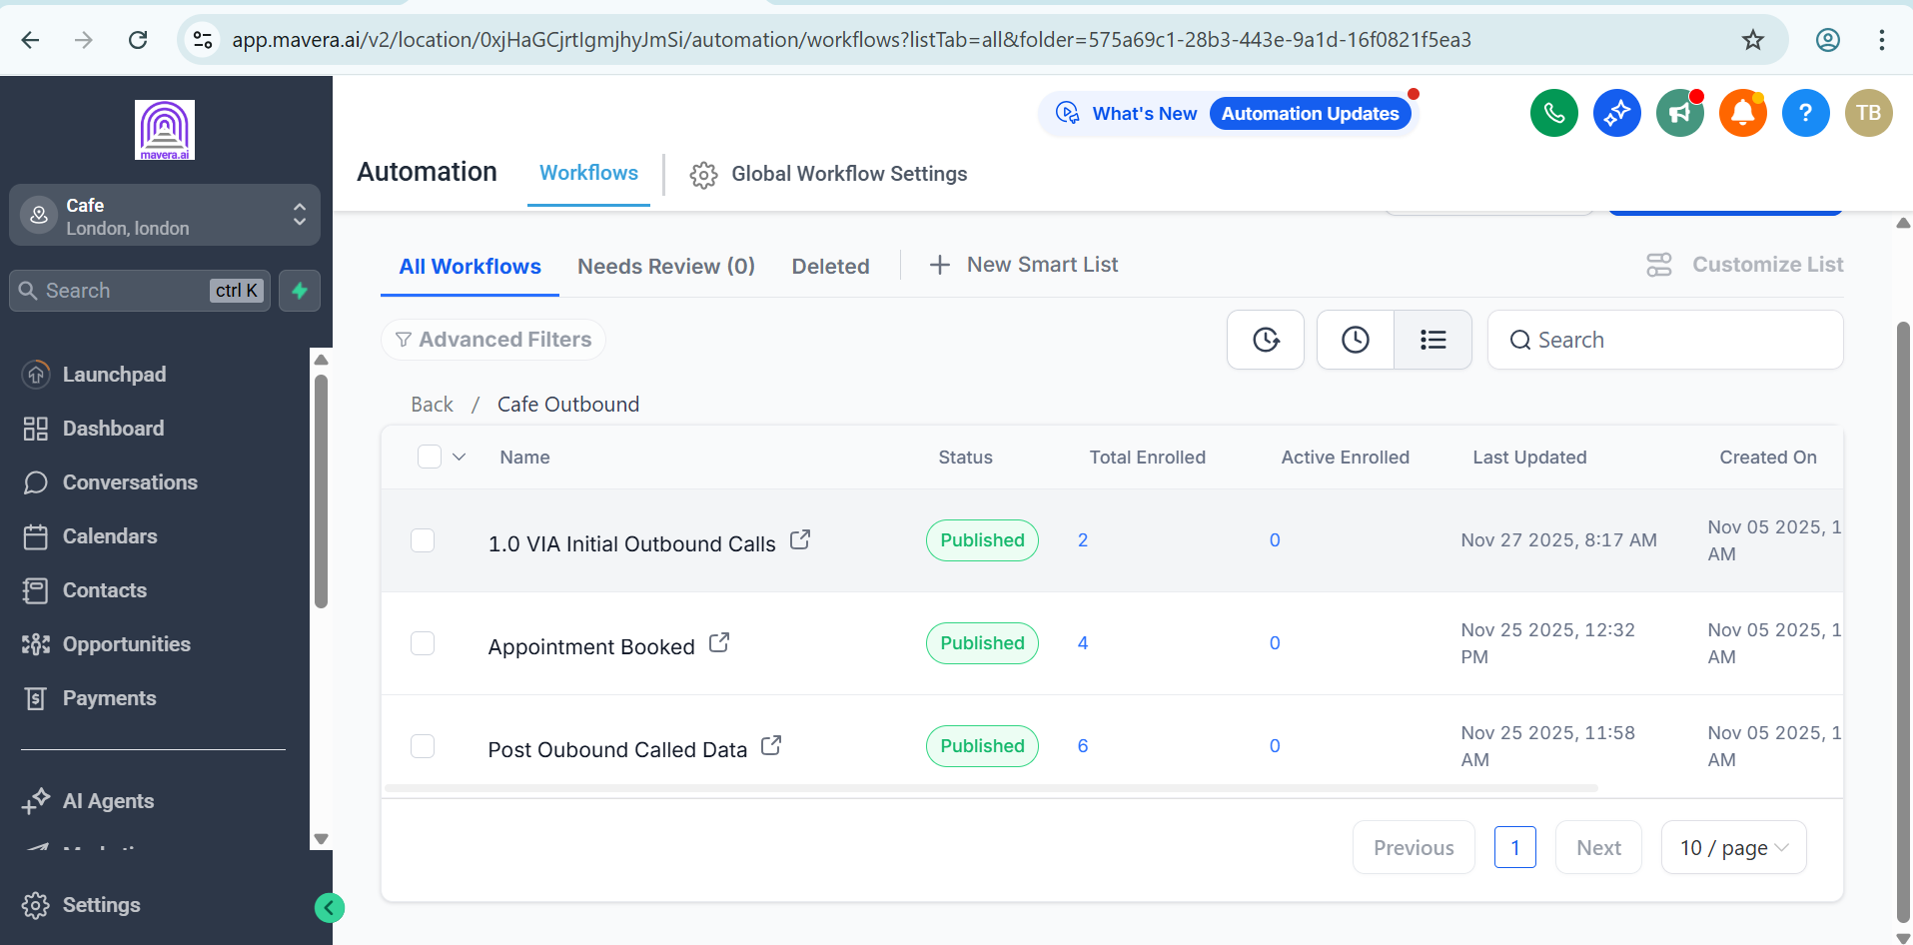
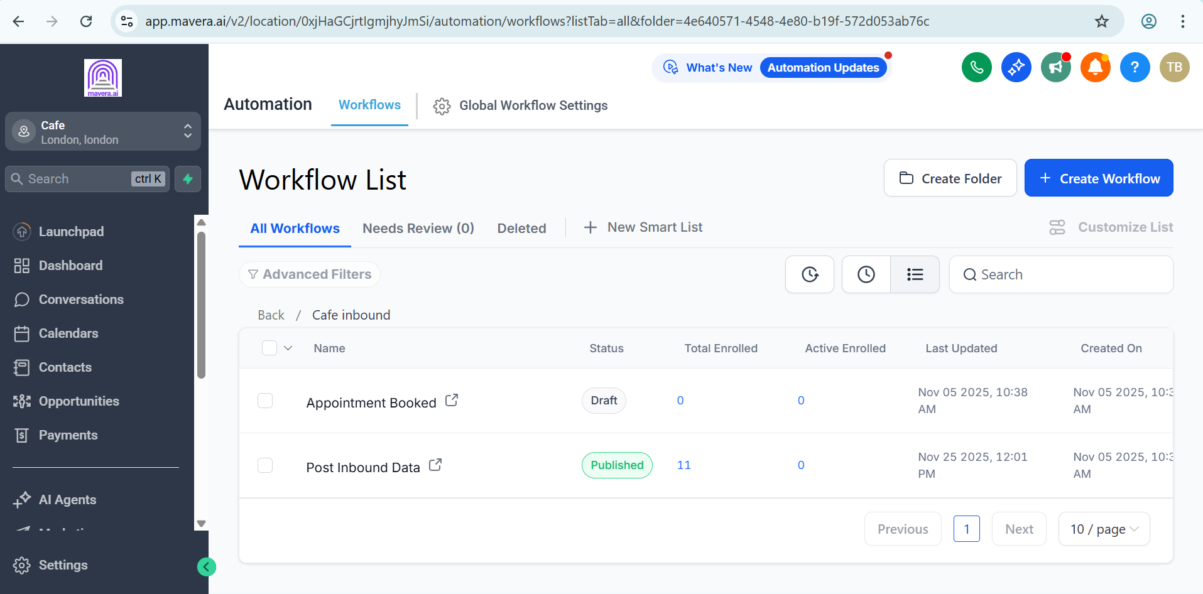
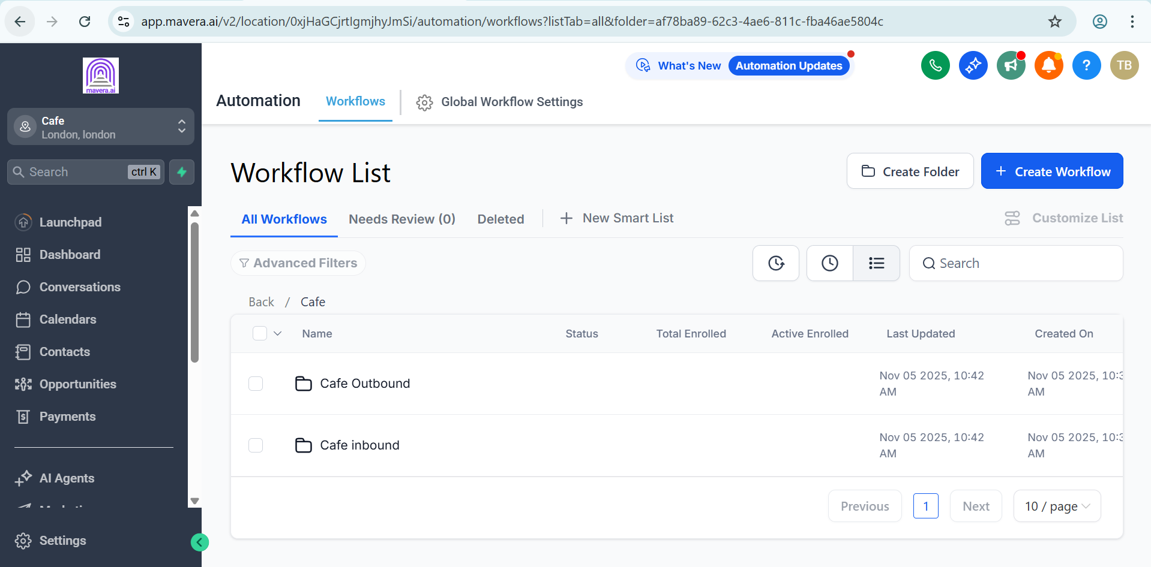
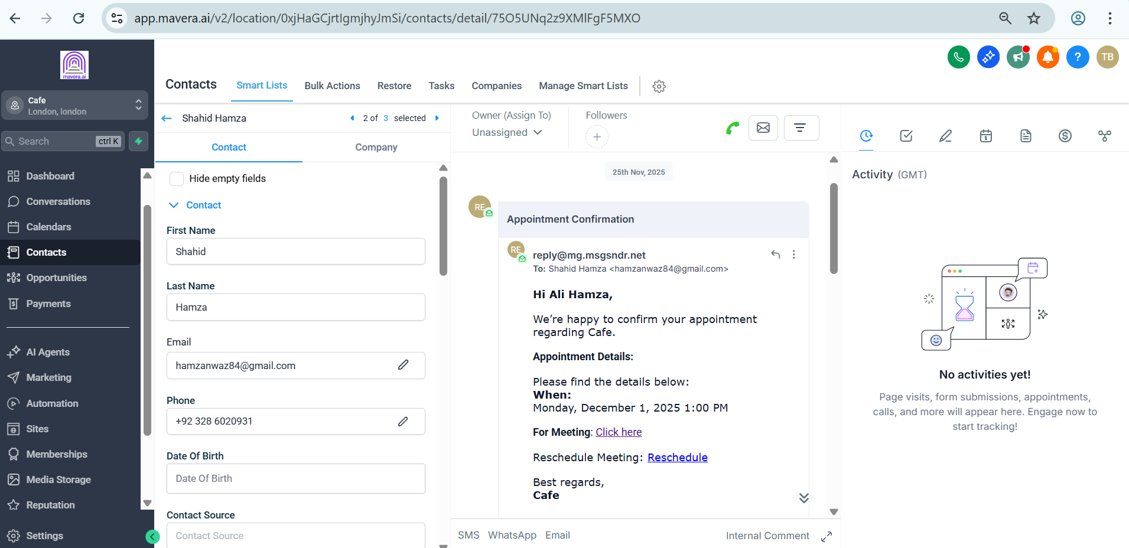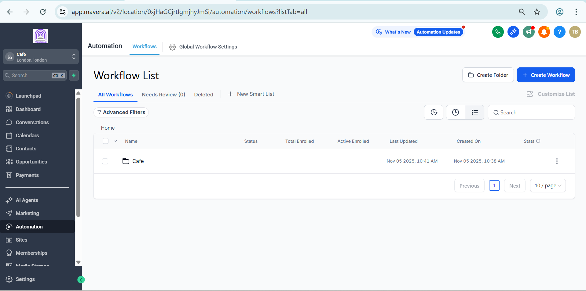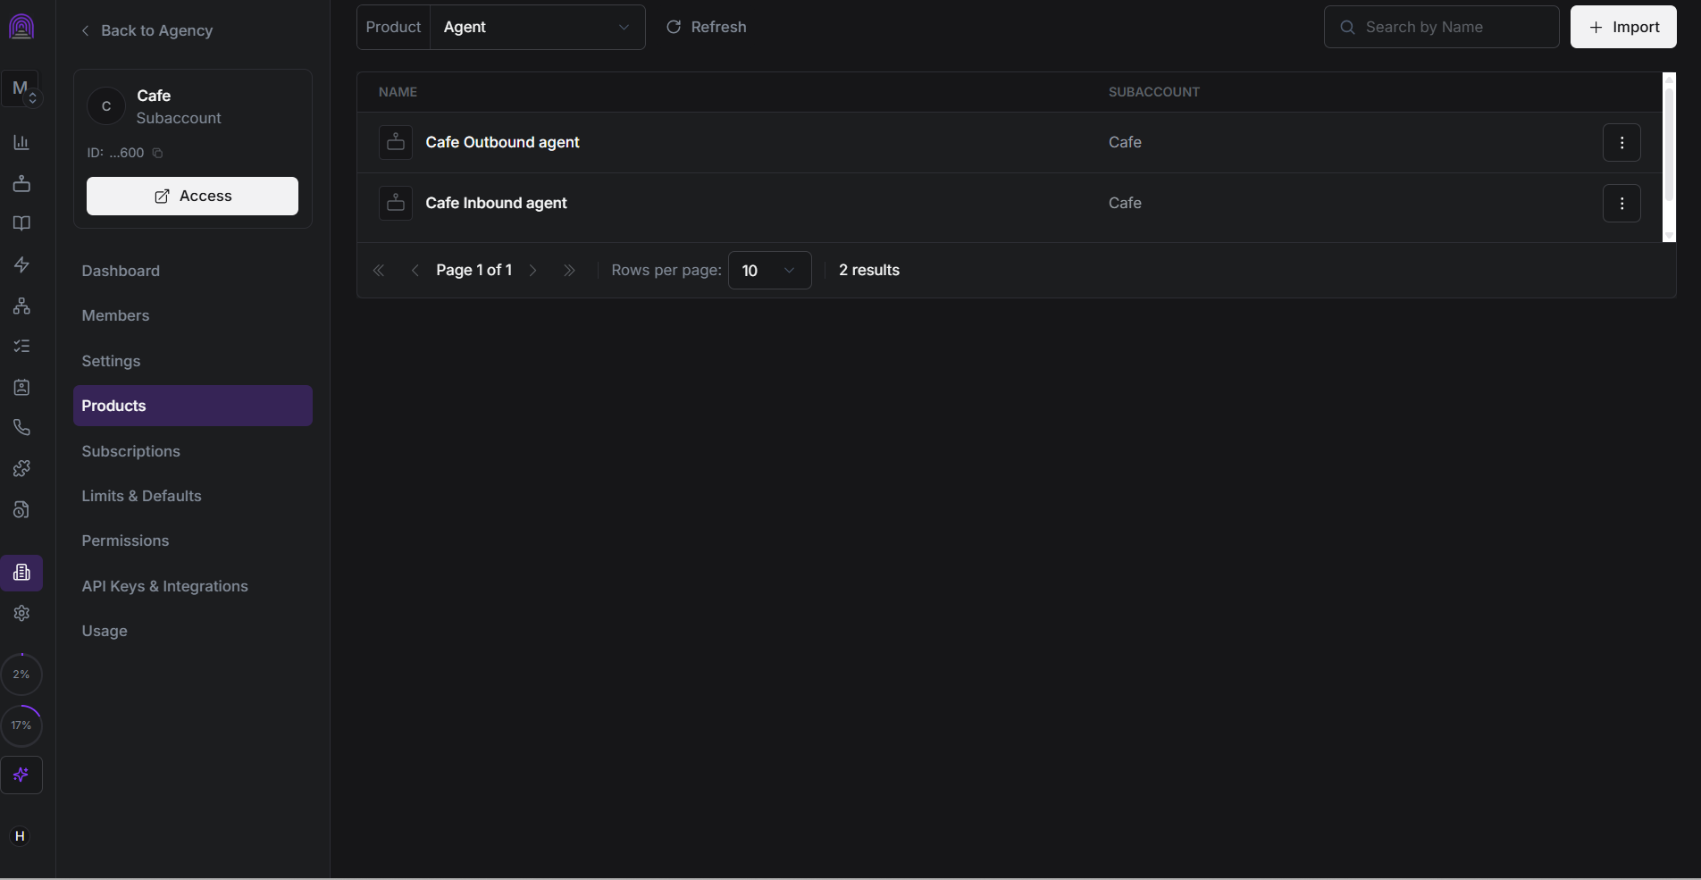

Subaccount Setup
A dedicated Cafe subaccount was configured with separate areas for:
• Inbound calls
• Outbound calls
• Appointment booking
• Post call data
• Customer communication

Voice Agents
Two separate Synthflow agents were configured:
• Cafe Inbound Agent
• Cafe Outbound Agent
The agents handle incoming and outgoing customer conversations and connect the results with the GoHighLevel CRM.

Inbound Automation
The inbound workflow includes:
• Incoming call handling
• Appointment booking
• Post inbound data processing
• CRM updates

Outbound Automation
The outbound workflow includes:
• Initial outbound calls
• Appointment booking
• Post outbound call data
• CRM updates

Appointment & Email
Once an appointment is booked, the customer record is updated and the required confirmation email is sent.
The confirmation includes the appointment details and provides the customer with the relevant meeting information.

Technology
• GoHighLevel
• Synthflow
• Voice Agents
• CRM Workflows
• Appointment Booking
• Email Automation

Result
A centralized cafe communication system connecting inbound calls, outbound calls, appointment booking, post call processing, and customer emails inside GoHighLevel.
The setup reduces manual handling and keeps customer interactions and appointments organized in one place.

